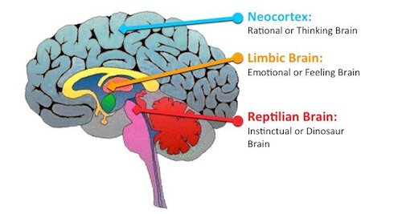

Our Multiple Brains

“Ontogeny recapitulates Phylogeny” – Ernst Haeckel

At Brain Advantage, we work with many regions of the brain. Whether utilizing sound to engage the temporal lobes or light to engage the occipital lobes, we employ a wide variety of inputs in an effort to improve the brain’s function. One of the key components of our process focuses on the prefrontal cortex. A deeper understanding of the human brain’s architecture is essential in order to truly appreciate the central role this magnificent region plays in orchestrating the successful function of the brain as a whole. With this insight comes an understanding of the havoc that can ensue with a poorly functioning prefrontal cortex.

While a working knowledge of the physical structures of the brain is certainly important, an understanding of the individual regions of the brain and their functions can shed new insight into the brain blah blah blah

Functionally, the brain the human brain is made up of four distinct centers of operation, each of which developed over millions of years of evolution. There exists a temporal order to the appearance of these regions which parallels the evolution of man. Despite the rich and dense connections that allows massive cross-talk between the individual regions of the brain, each is fully capable of functioning autonomously, accomplishing its unique mission with little, if any, input from the other sub-brains. While there is certainly some overlap anatomically between the different regions of the brain, each region has a unique task. When all of these regions are working in concert, all is well. When the system is out of synch mayhem can ensue.

The Reptilian Brain
I eat and kill; therefore I am.

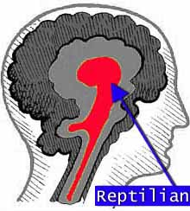

The reptilian brain, the oldest of the three, controls the body's vital functions such as heart rate, breathing, body temperature and balance. Our reptilian brain includes the main structures found in a reptile's brain: the brainstem and the cerebellum. This brain is programmed to breathe, eat and breed. The reptilian brain perceives the physical world without higher level thinking, emotions, or analysis. Dinosaurs have no need to define the context of an event. Under the guidance of the reptilian brain, an animal simply experiences an event and deals with it. Reptilian awareness takes everything literally. A twisted ankle is merely a twisted ankle, it is not a statement about luck, physical dexterity, nor the travails of an epic journey. There is no emotional content to the event. The primary mandate of this brain is the drive to survive. For many thousands of years, the reptilian awareness predominated. The reptilian brain is reliable but tends to be somewhat rigid and compulsive.

The Limbic System / The Mammalian Brain
I hoard and I mate; therefore I am.

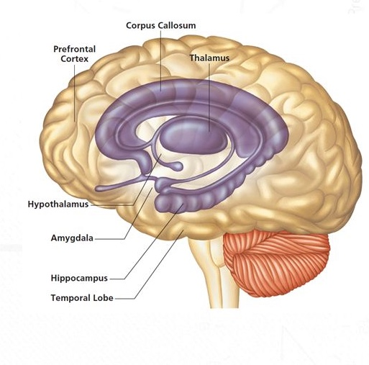

Enveloping and informing the reptilian brain is the Limbic System, which has been variously referred to as the mammalian brain, and the lower or primitive brain. We share the limbic brain with the Neanderthals, as well as with other primates and all mammals. The main structures of the limbic brain are the hippocampus, the amygdala, and the hypothalamus. The limbic system performs an even more sophisticated job of helping us survive. The region is focused on the four F’s of survival— feeding, fornicating, fighting, and fleeing. This is the region of the brain that allows us to store nuts or roots for the winter, recognize predators and bond with others to form family units and tribes. It’s the limbic brain that causes us to want to provide shelter and protect our young. Using this sub-brain, we bond with mothers and search for partners with whom to have sex. It can record memories of behaviors that produced agreeable and disagreeable experiences. As such, it is responsible for what are called emotions in human beings. This is also the operating center responsible for generating every limiting belief we hold about ourselves, including low self-esteem, self-doubt, guilt about sexuality, and fear of scarcity. We experience jealousy, betrayal, anger and resentment – all generated from the limbic brain.

The limbic brain’s programs so strongly influence our behavior that five out of the Ten Commandments are mandates to rein in our primitive instincts—killing, adultery, stealing, bearing false witness, and coveting. Within this brain lies the amygdala, an almond-shaped structure responsible for the instantaneous response to a perceived threat. The amygdala switches on the sympathetic nervous system, which gives us the energy to face our adversaries or outrun them. When the limbic system takes control, it forces the cortex off-line.

The Neocortex
I think; therefore I am.

The neocortex is our new brain—the most recent part of the brain to evolve. This is the brain of knowledge and science that scoffs at beliefs, insisting instead on hypotheses that can be tested out against reality. We share the neocortex with other mammals, but in humans its many folds enable it to be larger and capable of more advanced cognitive skills. The human neocortex thus added language and speech to our survival repertoire. This brain comprehends time, the seasons, as well as past and future, giving us the capacity for foresight. It is also responsible for poetry and music, which, although of no great survival value in the African savannah, were the ingredients for a future wisdom society and for survival of the wisest—the merchants, craftspeople, pyramid architects, scientists, and scribes. With the development of the neocortex, it was not the ablest hunter who got the most fertile females, the most land, or the most shekels, but the smartest one.

.

The Prefrontal Cortex
I AM; therefore I am.

When the prefrontal cortex is in charge of the system, we are able to experience how we are interwoven with and inseparable from the rest of the universe. With this brain, we understand there is more to life than mere survival and existence, more than just consumption, hoarding and technological toys. We can escape the clutches of the lower brains only if this more evolved brain takes the driver’s seat of the neural machinery. This level of consciousness is associated with the prefrontal cortex, where you perceive life to be filled with metaphors that help you understand your experiences and put them in a greater context. For example, when you meet up with your friends after your hike, you might tell the story of the twisted ankle as a tale of heroic challenge, a welcome sacrifice to partake of the extraordinary vistas at the mountaintop. While your reptilian brain is completely absorbed by taking the next step, at this level you notice universal elements in that hike. It is no longer a walk; it has become a journey, and as such it parallels every great journey undertaken. Your feelings are likely to shift when you take this perspective. Instead of cursing the person who encouraged you to start up the path, or muttering about the stupid root you tripped over, you recognize that all paths have unexpected twists and turns and obstacles. You know that an experience that yields wisdom or insight is always of value even if it requires a certain amount of effort. In this state, you approach life like a poet, seeing beauty and mystery everywhere and feeling a sense of awe. This brain helps you lose your sense of separateness as your identity merges with the mountain and the clouds above. The pain in your ankle recedes as you dwell in the beauty of the path. Although the experience of communion may last for only a few moments, its effects last a lifetime and forever alter your perception of yourself and the world.

How then do these separate yet united brain centers relate to the others? One could not be faulted for assuming the existence of a top-down hierarchical structure whereby information taken in by various sensors flows upwards where it is integrated with input from the other brain centers and interpreted by the highest order brain. Armed with this input and assessment, the upper management sets about passing down edicts and directions to be carried out by the lower order brain centers. For better or worse, the informational architecture of our brain is far more complex and subtle than we might imagine.

Each of these three sub-brains—the reptilian brain, the limbic brain, and the neocortex—can be more accurately thought of as a holon (from the Greek word holos, meaning “whole”), a unit that is complete within itself and also a part of a larger organic structure. Holons are autonomous, self-reliant units that handle local decision making without asking higher authorities for instructions.

All of these brains perform their biologically programmed functions, yet they submit to the guidance of the highest brain, in the same way that our stomach has its job but does not set the agenda for our day. The term “hierarchy” isn’t quite right for the interrelationship of parts of the brain, because it doesn’t reflect the feedback that occurs in a living system; holarchy better expresses the fact that the lower brains often inform the higher brains rather than simply obeying them. The reptilian brain has to continue regulating breathing and body temperature automatically, while the mammalian brain has to seek partnerships without making the search for relationships our only goal. Likewise, the neocortex offers us the ability to reason, to think logically, and to discover music and science, without making our lives revolve around technology or be limited by our intellect.

Each of the three sub-brains—the reptilian brain, the limbic brain, and the neocortex serve the higher agenda of the fourth brain, the Prefrontal Cortex. When all is right and all systems are balanced, the prefrontal cortex functions as the system’s integrator of our biological supercomputer. However, when one of the sub-brains is traumatized by emotional or environmental factors, its programs will override the agendas of the higher brains.

Early childhood emotional trauma can easily lead to an imbalance within the holarchy. Lacking a sense of safety, the limbic brain functions in overdrive and sets the agenda. Under the guidance of the limbic brain we are preoccupied with survival. Jealousy, anger, resentment, fear and an overriding sense of scarcity direct our thoughts and behaviors.

